***Documentation***

**Title: Drone Training**

**Project description:**

FLOSSK launched a Drone Training program to offer participants practical experience with drone technology, covering safe operation, applications like aerial photography, and relevant regulations. The program fostered collaboration among attendees, enhancing their confidence in using drones. Feedback indicated a positive experience, with many expressing interest in future training opportunities.

**Activities:**Key activities:

* To provide comprehensive training on drone operation, safety protocols, and relevant regulations.
* To enable participants to acquire practical skills in piloting drones and conducting aerial photography and videography.
* To grow interest in the field of drone technology among participants, encouraging future career paths in this area.

**Photos:**

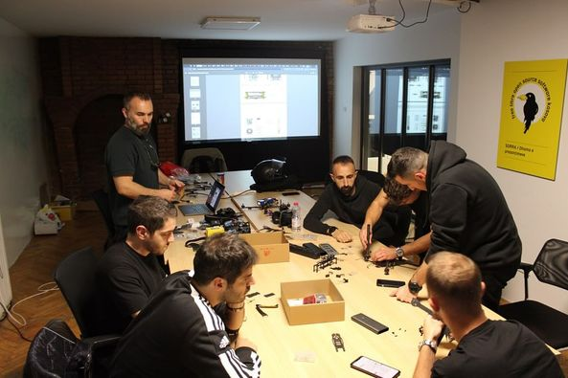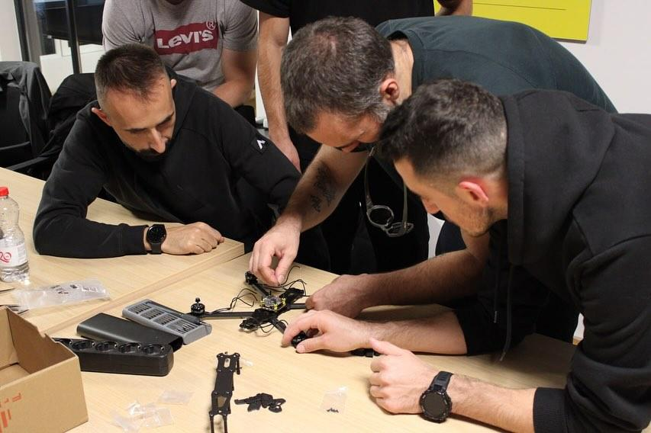

**Beneficiaries:**

The Drone Training program benefited students, hobbyists, and aspiring professionals by providing hands-on experience with drone operation and aerial photography. Participants gained confidence in using drone technology, and many showed interest in pursuing further training.

**Partners:**

* N/A

**Budget:**€1820

**Project duration**:

Not completed

*This document is FLOSSK intellectual property - Do not share without authorization from FLOSSK.*